Assignment 1
Group 4
25.11.2025
Jasmijn Brouwer
Katja Dinnissen – 1567381
Mehrshad Ghorbanisharif

Part 1 – Formulating and Solving the Basic Routing problem
  - TSP formulation
MTZ:
- constraints
- goes and leaves once
- no customer visited twice/ no overlap
- no subtours allowed
You only get subtour if you incl. cutting edges in the DFJ

Other:
- line 53 (enter), line 54 (exits) only once
- line 56-60 no subtours allowed
  - line 60 (Jasmijn): MTX_model.addConst(u[i] <= M_big -1)
- line 65
is the assignment with one vehicle only? – yes in part 2 we add capacity

Difference MTZ/ DFJ
With the MTX you also get these constraints: u represents the node problem, not incl in DFJ
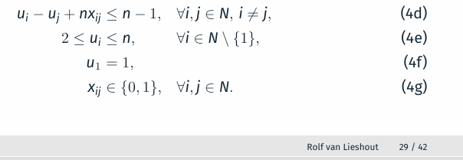
Tour starts at depot (u1), all other customers, are ordered after that
The MTX in case x(ij) = 1 then i goes directly to j?
For x(ij) = 1
U(i) – u(j) + n*1 = n-1
U(i) + 1 <= u(j)
- if we go from I to j ; then j must have a higher order number than I
For X(ij) – 0
U(i) – u(j) <= n-1

- Instance to ensure correctness:

Formulating DFJ

Conclusion: DFJ performs better for bigger lists
- bc DFJ has a strong LP relaxation, while MTZ has a very weak one
  - meaning in MTZ there;s a lot of guesswork in the programming of figuring out where to go from each customer. – this is time intensive as each option has to be considered
  - for DFJ this is faster a
  - Improving DFJ

